PROJECT REPORT
Comprehensive House Price Analysis Using Tableau & Flask
Team Leader: Jaldu Sri Vani
Team member: M Samuel Paul
Team member: Maddula Leela Naga Varshita
Team member: Malla Gopichand

1. INTRODUCTION
1.1 Project Overview
The Comprehensive House Price Analysis project aims to analyse housing market data using Tableau for interactive data visualization and Flask for web deployment. The objective of this project is to extract meaningful insights from housing data such as sale prices, renovation history, house age, and structural features like bedrooms, bathrooms, and floors.
The system provides an interactive dashboard and story interface that enables users to explore housing patterns dynamically. The project integrates business intelligence with web development to create a professional, responsive analytical web application.

1.2 Purpose
The purpose of this project is to:
- Analyse housing trends using data visualization.
- Identify the impact of renovation on house pricing.
- Understand how structural features influence property value.
- Provide an interactive web-based analytics platform.
- Demonstrate integration of Tableau with Flask for deployment.

2. IDEATION PHASE
2.1 Problem Statement
Real estate stakeholders require effective tools to analyse housing price trends and understand the factors affecting property value. Raw housing datasets are complex and difficult to interpret without proper visualization tools.
This project aims to design an interactive analytical system that simplifies housing data interpretation through dashboards and storytelling.
2.2 Empathy Map Canvas
Target Users:
- Real estate analysts
- Property buyers
- Real estate agencies
- Investors
User Needs:
- Quick overview of market trends
- Identification of high-value properties
- Understanding renovation impact
- Feature comparison across house age groups
Pain Points:
- Large datasets difficult to analyze
- Lack of interactive filtering
- Static reports without insight clarity
2.3 Brainstorming
Several ideas were considered:
- Basic data report
- Static graphs
- Machine learning prediction model
- Interactive visualization dashboard
Final decision:
Develop an interactive Tableau dashboard integrated into a Flask web application for professional deployment.
3. REQUIREMENT ANALYSIS
3.1 Customer Journey Map
- User accesses web application.
- Navigates through Home, About, Dashboard, and Story pages.
- Interacts with filters.
- Analyses KPIs and visual insights.
- Draws conclusions about housing trends.
3.2 Solution Requirements
Functional Requirements:
- Load housing dataset.
- Clean and preprocess data.
- Generate KPIs.
- Create analytical visualizations.
- Provide interactive filters.
- Deploy dashboard on web.
Non-Functional Requirements:
- Fast loading time.
- Responsive UI.
- Clear visual design.
- No lag during filter interaction.
3.3 Data Flow Diagram (Textual Representation)
Housing CSV Dataset
↓
Tableau Data Cleaning
↓
Calculated Fields Creation
↓
KPI & Analytical Charts
↓
Dashboard & Story Creation
↓
Publish to Tableau Public
↓
Embed in Flask Web Application
↓
End User Interaction
3.4 Technology Stack
- Tableau Desktop Public Edition
- Tableau Public
- Python 3.x
- Flask Framework
- HTML
- CSS
- JavaScript (Tableau API)

4. PROJECT DESIGN
4.1 Problem Solution Fit
The system transforms raw housing data into interactive insights. It provides stakeholders with actionable analysis regarding renovation trends and structural impact on pricing.
4.2 Proposed Solution
The proposed solution consists of:
- Data preprocessing in Tableau
- KPI and analytical dashboard creation
- Story-based visualization
- Web integration using Flask
- Responsive UI design
4.3 Solution Architecture
Architecture Components:
- Data Layer – Housing CSV dataset.
- Processing Layer – Tableau data cleaning and calculated fields.
- Visualization Layer – Dashboard & Story.
- Deployment Layer – Tableau Public.
- Web Integration Layer – Flask web application.

5. PROJECT PLANNING & SCHEDULING
Phase 1 – Dataset Collection
Phase 2 – Data Cleaning & Transformation
Phase 3 – KPI & Visualization Development
Phase 4 – Dashboard & Story Creation
Phase 5 – Web Integration
Phase 6 – Testing & Optimization
Phase 7 – Documentation & Presentation

6. FUNCTIONAL AND PERFORMANCE TESTING
6.1 Functional Testing
- Dataset loads correctly
- Calculated fields working
- Filters functioning properly
- All visualizations display correctly
- Navigation between pages works

6.2 Performance Testing
- Total Records Loaded: 21,613
- Dashboard Load Time: Optimized
- Filter Response: Instant
- Story Rendering: Smooth
- No UI lag observed

7. RESULTS
7.1 Output Screenshots
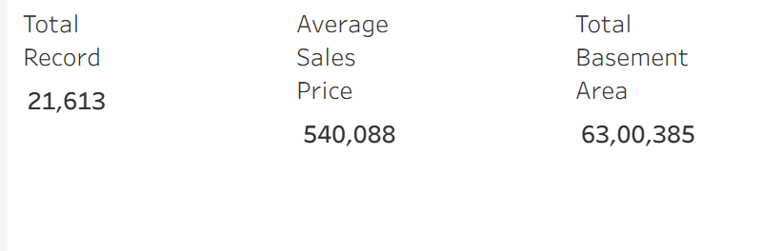
- KPI Dashboard

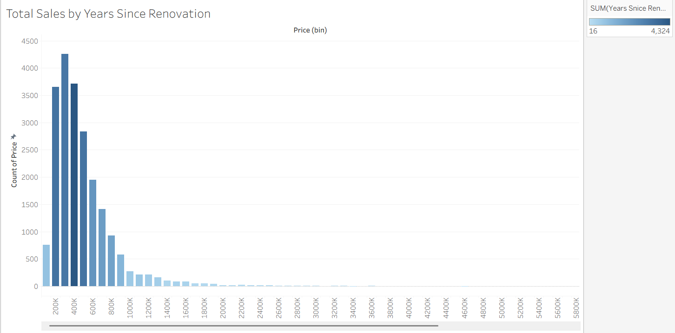
- Bar Chart

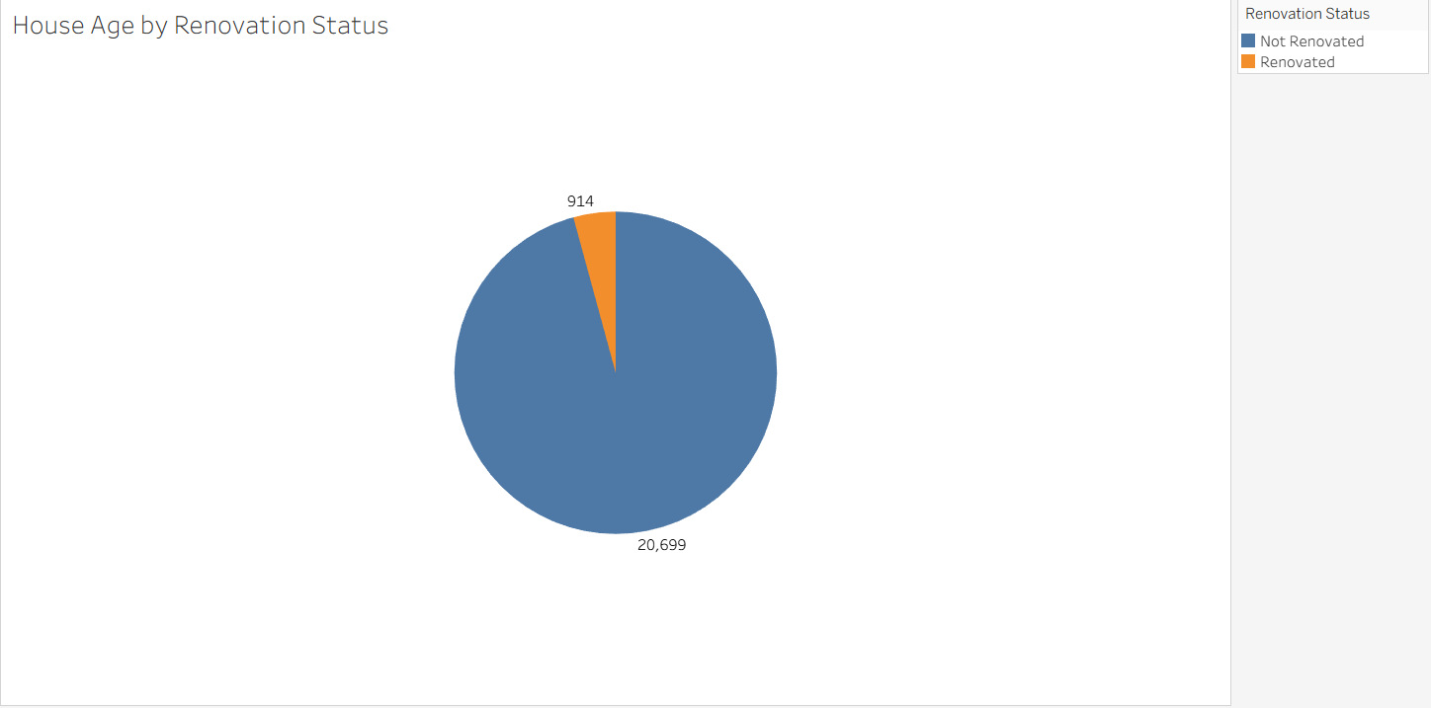
- Pie Chart
- Grouped Bar Chart
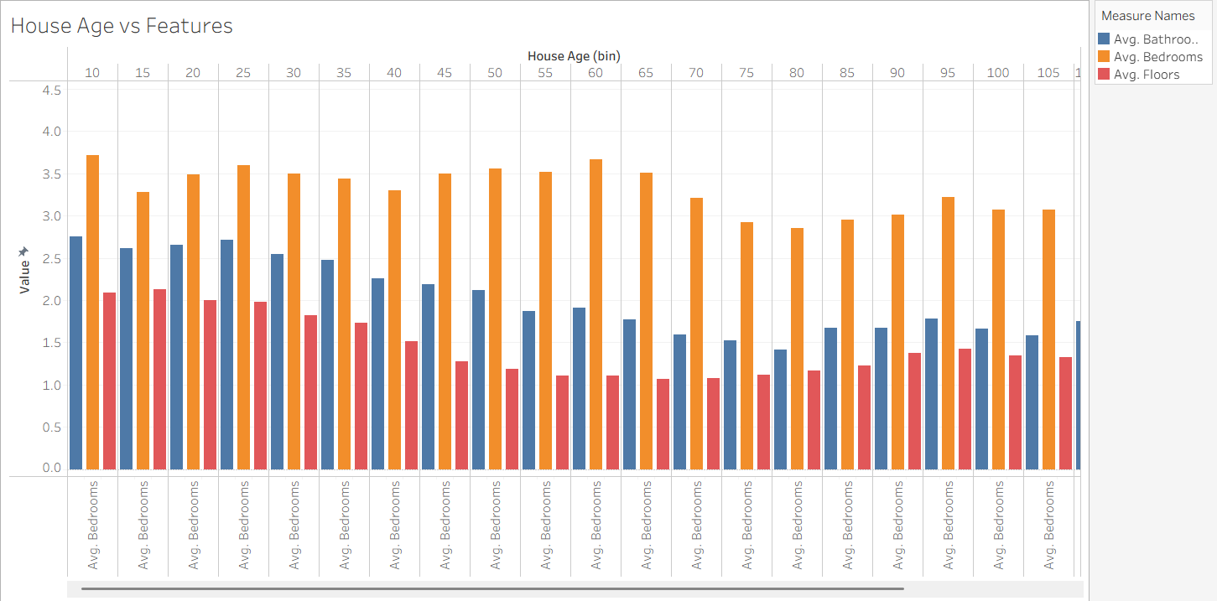

- Story Page
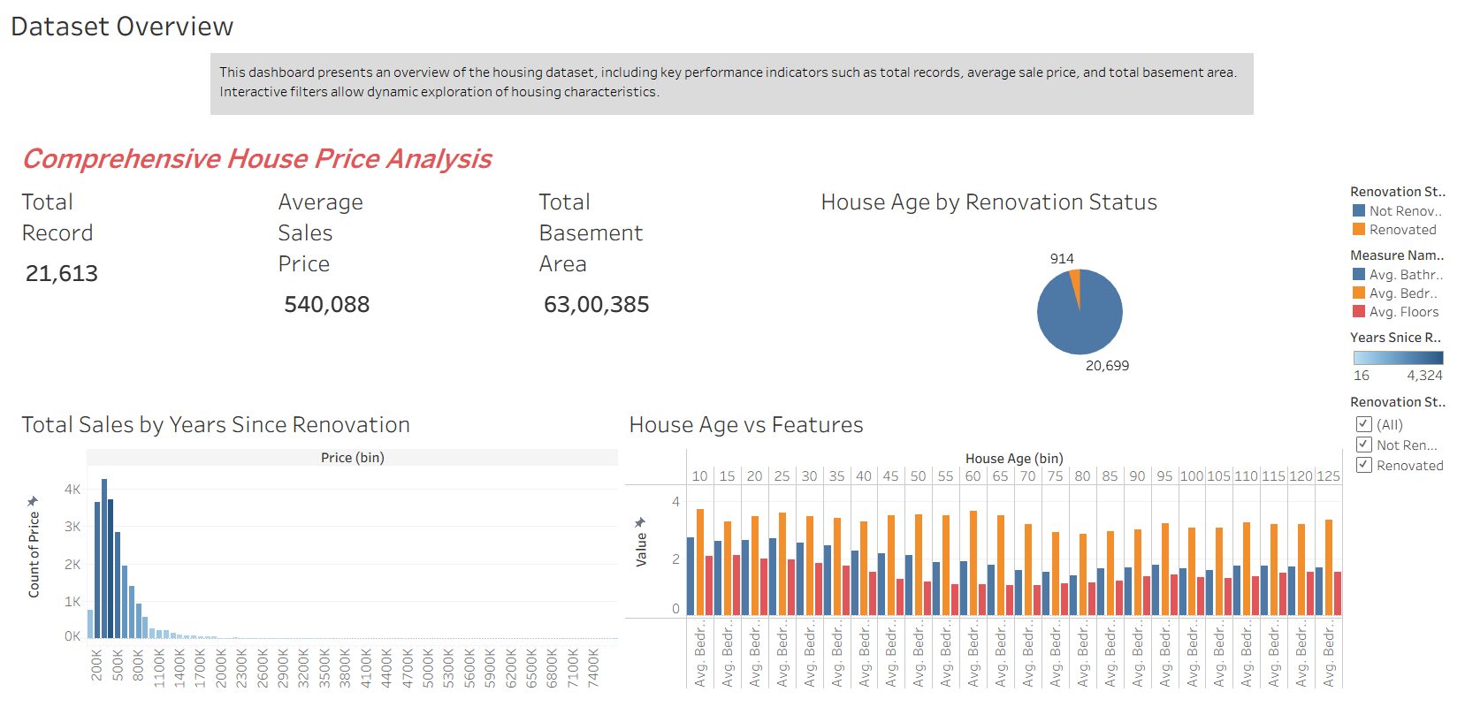

- Flask Web Application
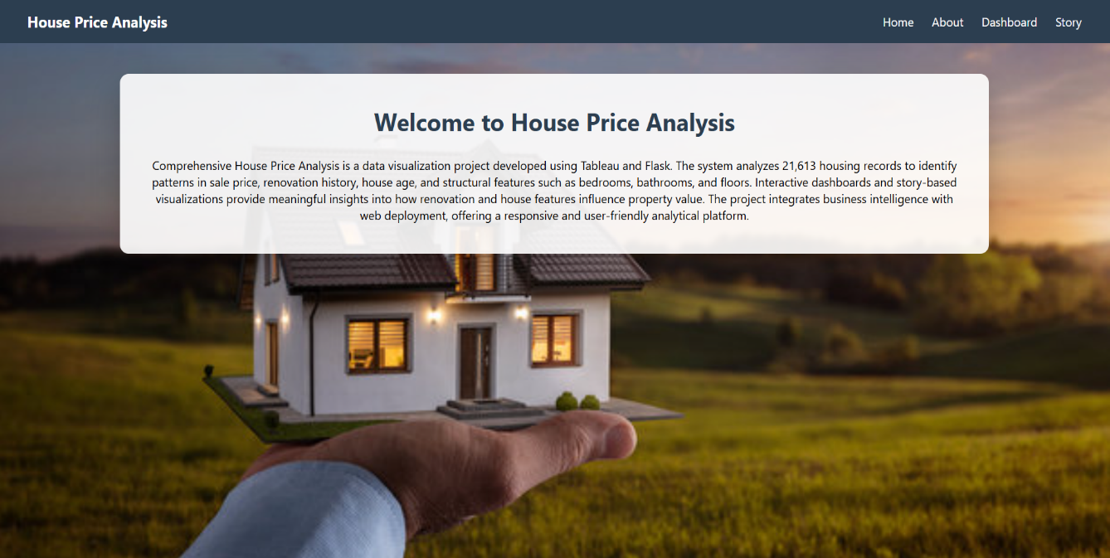

Analytical Results
- Majority of houses are non-renovated.
- Recently renovated houses show higher sale price ranges.
- Newer houses contain more bedrooms, bathrooms, and floors.
- Structural upgrades positively influence housing value.

8. ADVANTAGES & DISADVANTAGES
Advantages
- Interactive visualization
- Easy interpretation of housing trends
- Web-based deployment
- Responsive UI
- Scalable design
Disadvantages
- Dependent on Tableau Public server performance
- Story pages load slower compared to dashboard
- Limited customization without paid Tableau version

9. CONCLUSION
The Comprehensive House Price Analysis project successfully demonstrates the use of data visualization techniques to analyse real estate data. The integration of Tableau with Flask enables interactive analytics through a web interface. The system provides valuable insights into renovation impact, house age distribution, and structural feature trends.
The project effectively combines data analytics and web development to deliver a professional analytical platform.

10. FUTURE SCOPE
- Implement Machine Learning for price prediction
- Add Geographic heatmaps
- Real-time database integration
- User authentication system
- Advanced financial metrics
- Mobile app integration

11. APPENDIX
Dataset Link
https://www.kaggle.com/datasets/harlfoxem/housesalesprediction
GitHub Repository
https://github.com/SRIVANI-JALDU/House-Price-Analysis
Tableau Public Dashboard Link
https://public.tableau.com/views/ComprehensiveHousePriceAnalysisSrivaniJaldu/ComprehensiveHousePriceAnalysis?:language=en-GB&:sid=&:redirect=auth&:display_count=n&:origin=viz_share_link

